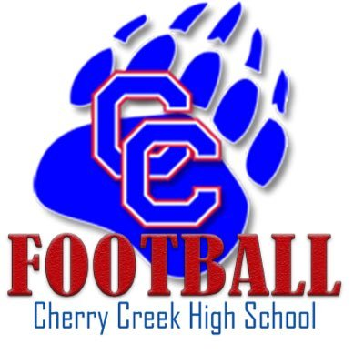
Cherry Creek Bruins Football
Fundraising Program

The purpose of our Touchdown Club is to help provide a great experience for any child who plays in the CCHS football program. Without funds being committed from the school or district to assist the program, we must rely on player fees, donations & sponsorships to ensure that great experience.

The coaches of Cherry Creek Football strive to have the best and safest equipment. Every year helmets and shoulder pads are professionally inspected and reconditioned, a very expensive, but necessary procedure to ensure every player’s safety! The Touchdown Club provides a team meal before every Varsity game to promote unity with our football family. Additionally, costs for uniforms, travel, summer camp, administration of the program, game filming, photography, coach communication systems for in-game all are costs that come from the registration and fundraising. The Touchdown Club’s efforts go a long way to ensuring these facets of the program are consistent year after year.

We, as a club, are able to make our decisions on how we want to raise and spend funds for our team and coaches. We depend on our parents/guardians to be involved, volunteer and do everything necessary for our group to keep our non-profit status to give our student athletes the best opportunities possible.

The anticipated budget per season is around $250,000. This breaks down to an approximate cost per player of $1,700. We charge $1000 player fee to each family and work hard to raise the additional funds through donations, corporate sponsorships and fundraising activities throughout the Summer. Our budget is monitored by the annually elected board as well as the athletic director of Cherry Creek High School. Please be aware every dollar is responsibly spent, but also realize it takes every family to help fundraise that amount annually to make this program successful.

We know that each family has different circumstances: some fundraise everything, some fundraise a portion and donate the rest and some others donate the entire amount. We appreciate support no matter how it is raised. Most importantly any amount donated to the program is eligible as a tax-deductible benefit. It is important for all players, parents, and families to participate as much as needed or when possible, to help the entire team. We encourage everyone to over-fundraise to both help your own player and to transfer funds to other teammates who may not be so fortunate to easily meet their own fundraising goals. We truly are a family and encourage everyone to help their football family members any way that they can.

Cherry Creek Touchdown Club

Year Long Team Fundraising

**Funds raised through our King Soopers Cards & AmazonSmile program go to the general fund for the Touchdown Club to be used across all teams (please see our Corporate & Individual Sponsorship program below on how you can lower your player registration costs)

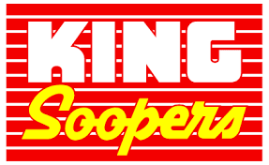King Soopers Cards- This is our largest “all team” effort fundraiser. King Soopers will donate 5% back to the team for all purchases made at King Soopers and all City Market Grocery stores across the country. We ask all parents, players and extended family to sign up with their current phone number they already use to partake in King Soopers rewards program.

To Use the King Soopers or City Market Community Rewards Program:
Simply encourage your participants to visit the appropriate link below..
- For King Soopers Stores - go to http://www.kingsoopers.com
- For City Market Stores - go to http://www.citymarket.com
Once logged into their King Soopers or City Market account they can search for Cherry Creek Touchdown Club Inc either by name or GC540 and then click Enroll. New users will need to create an account which requires some basic information, a valid email address and a loyalty card.

*Customers must have a registered King Soopers or City Market loyalty card account to link to your organization.
*If a member does not yet have a King Soopers or City Market loyalty card, please let them know they are available at the customer service desk at any King Soopers or City Market

REMEMBER, purchases will not count for your organization until after your participants register their loyalty card.
Participants must swipe their registered King Soopers or City Market loyalty card or use the phone number that is related to their registered King Soopers or City Market loyalty card when shopping for each purchase to count.
Amazon Smile: This is an “all team” fundraiser, which means all proceeds go to the general program and not individual accounts, but your participation keeps our individual player fundraising goal low. AmazonSmile is a website operated by Amazon that lets customers enjoy the same wide selection of products, low prices, and convenient shopping features as on Amazon.com. The difference is that when customers shop on AmazonSmile (smile.amazon.com), the AmazonSmile Foundation will donate 0.5% of the price of eligible purchases back to our team’s nonprofit account.
Step #1: Go to Amazon.com & under “Accounts & Lists” go to “Your AmazonSmile”
Step #2: Pick your charity and type in “Cherry Creek Touchdown Club”
Step #3: Utilize your new AmazonSmile Prime when ordering

Individual Fundraising via Corporate & Individual Sponsorships

*Families have the opportunity to lower their player registration costs by bringing in new corporate or individual sponsors to the program. For every sponsor secured by a player/family, we will discount 50% of the sponsorship value from your player registration cost in 2021 up to a $1,000 value. (Discounts do not carry-over into subsequent years)

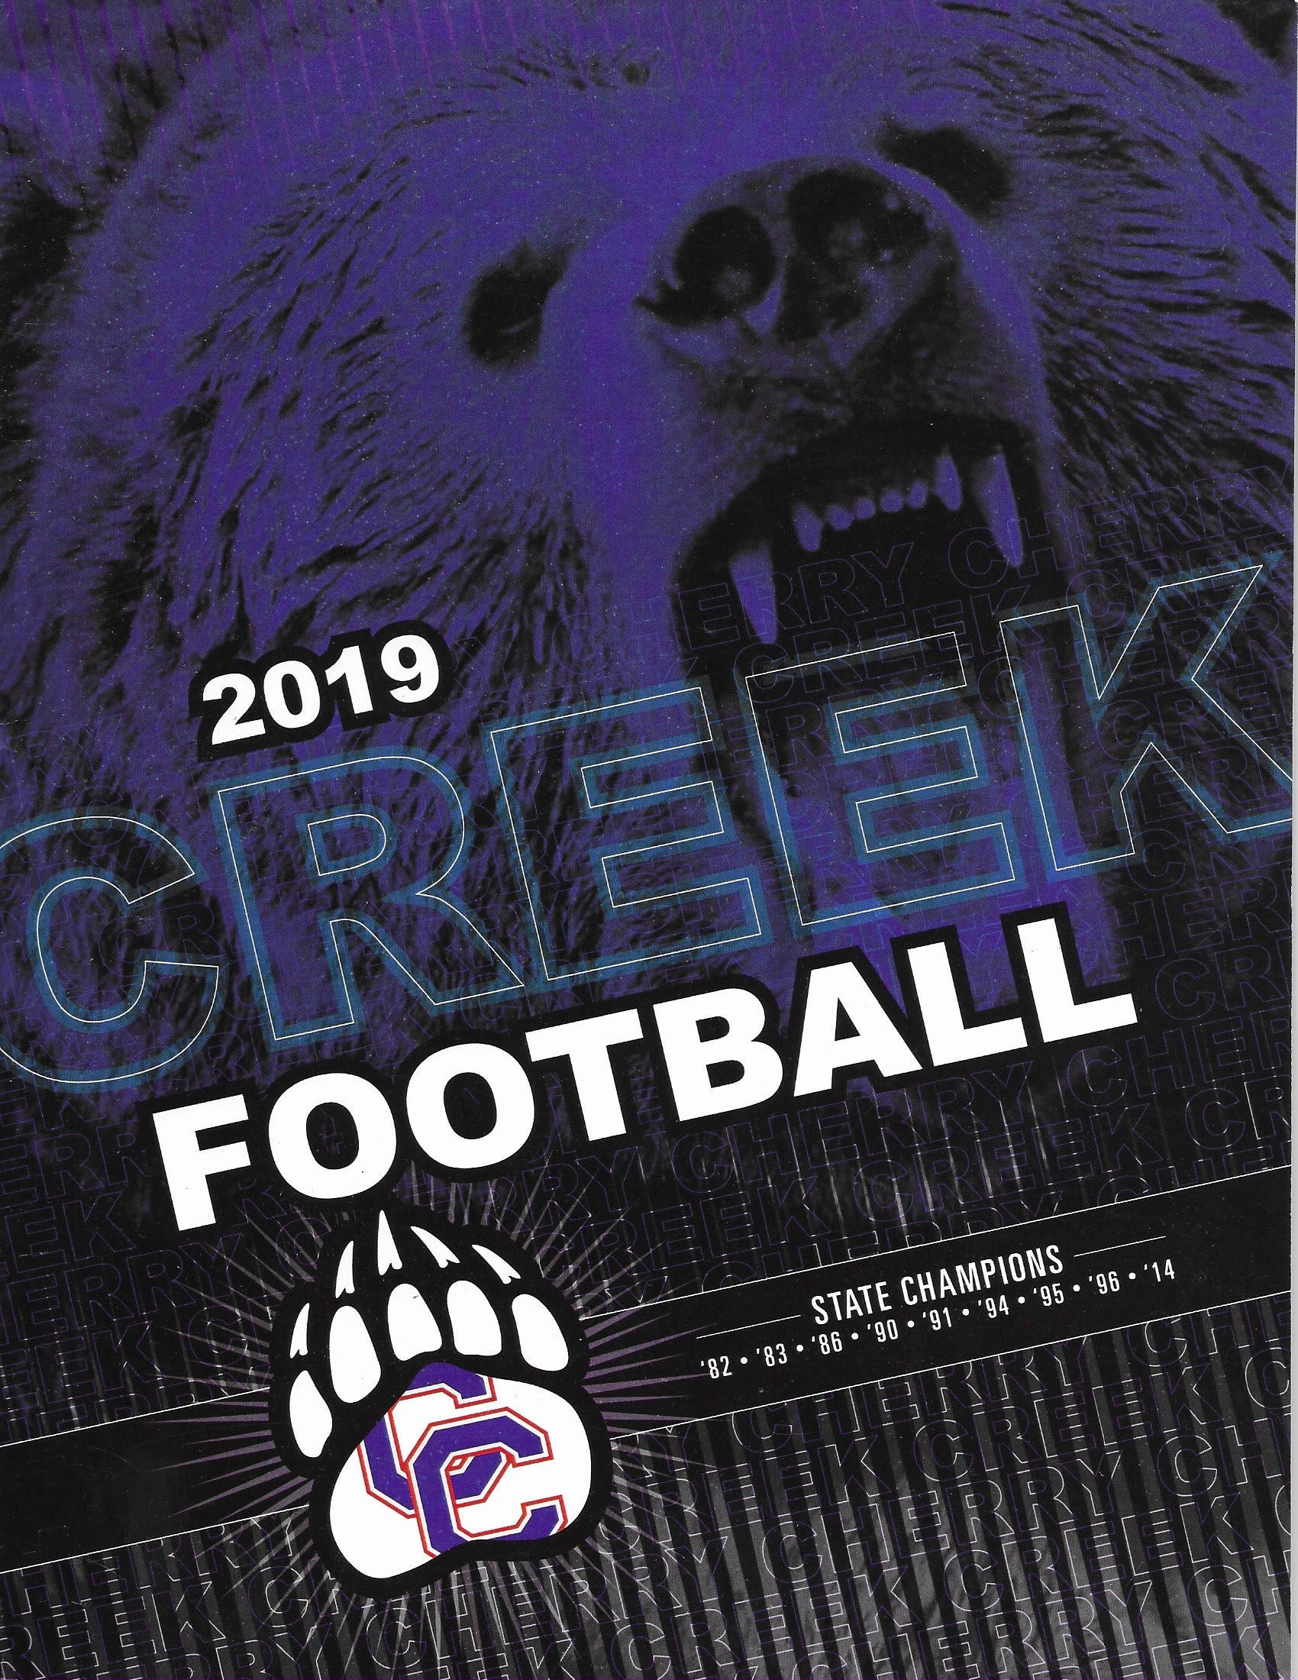

Corporate Sponsorship Ad Program- Great way to promote your business, the business you work for or the businesses within the community of Cherry Creek High School by offering them the highest level of community visibility of advertising at our games in our professionally printed program book. Your player will receive % of the donated amount and the remaining % will be used for advertising costs. To be added to our program book, applications need to be in by July 1st.
Invite potential sponsors such as local dentists, orthodontists, restaurants, realtors, landscapers, personal trainers, local gyms, etc. to donate by choosing from multiple sponsorship levels ranging from $500-$2500. In exchange we will offer multiple advertising options from:
- Sideline Logo Signage
- Professional Printed Ad in our yearly Program
- Recognition by the announcer at home games
- Opportunity to distribute products or info about services provided @ home games
- Opportunity to be involved in other Booster Fundraisers throughout the year
- Social Media and Website Recognition

- For more information please reach out to Bill @ president@cherrycreekfootball.org to obtain the sponsorship sign-up form.

Potential Sponsor Suggestions:

Dentists Photographers Chiropractors Gyms Oil/Gas Companies
Orthodontist Driving Schools Restaurants Yoga Studios Hospitals
Hair Stylists Landscapers Catering Companies Massage Therapists Urgent Care Facilities
Realtors Lawyers Community Colleges Personal Trainers Construction Co.

